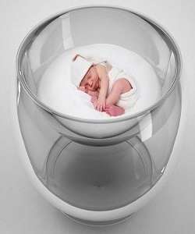

Modern Baby Cradle

$92.11

Availability: In stock

**Description:**

Modern cute circle bubble baby bed cradle. The comfortable cushioning of the headboard gives your baby body all the support needed to sit and relax. Available in multiple colors and sizes.Solid wood have inherent natural colors and variations that present a number of beautiful possibilities for your room.Our wood come in a wide range of stylish variations, including cherry, hickory, maple, birch and red oak.